**EMS(GOR)**

Steps to make an API to mail user details to the User in LocalHost(Xampp Server).

**1.Setting up an account**

For Demo purpose I use Gmail Account

Create a gmail account for sending Emails.

**2. Setting Up the Gmail Account**

After account is been created we have to setup gmail account to used by our app.

For this purpose we enable to options.

**1.Enabling IMAP**

Go to gmail ac –setting symbol-settings

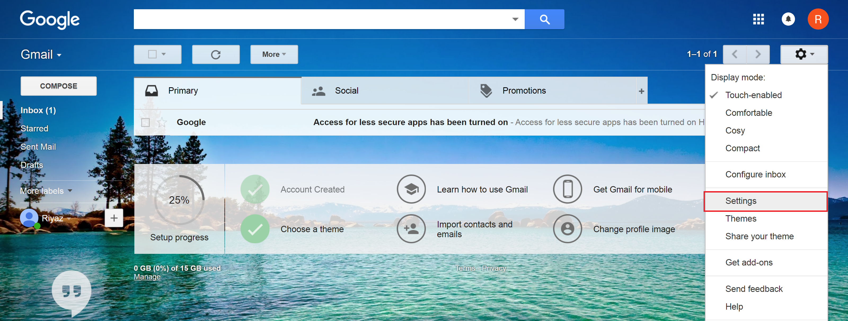

Click on Forwarding and POP/IMAP

Enable the IMAP

Save Changes

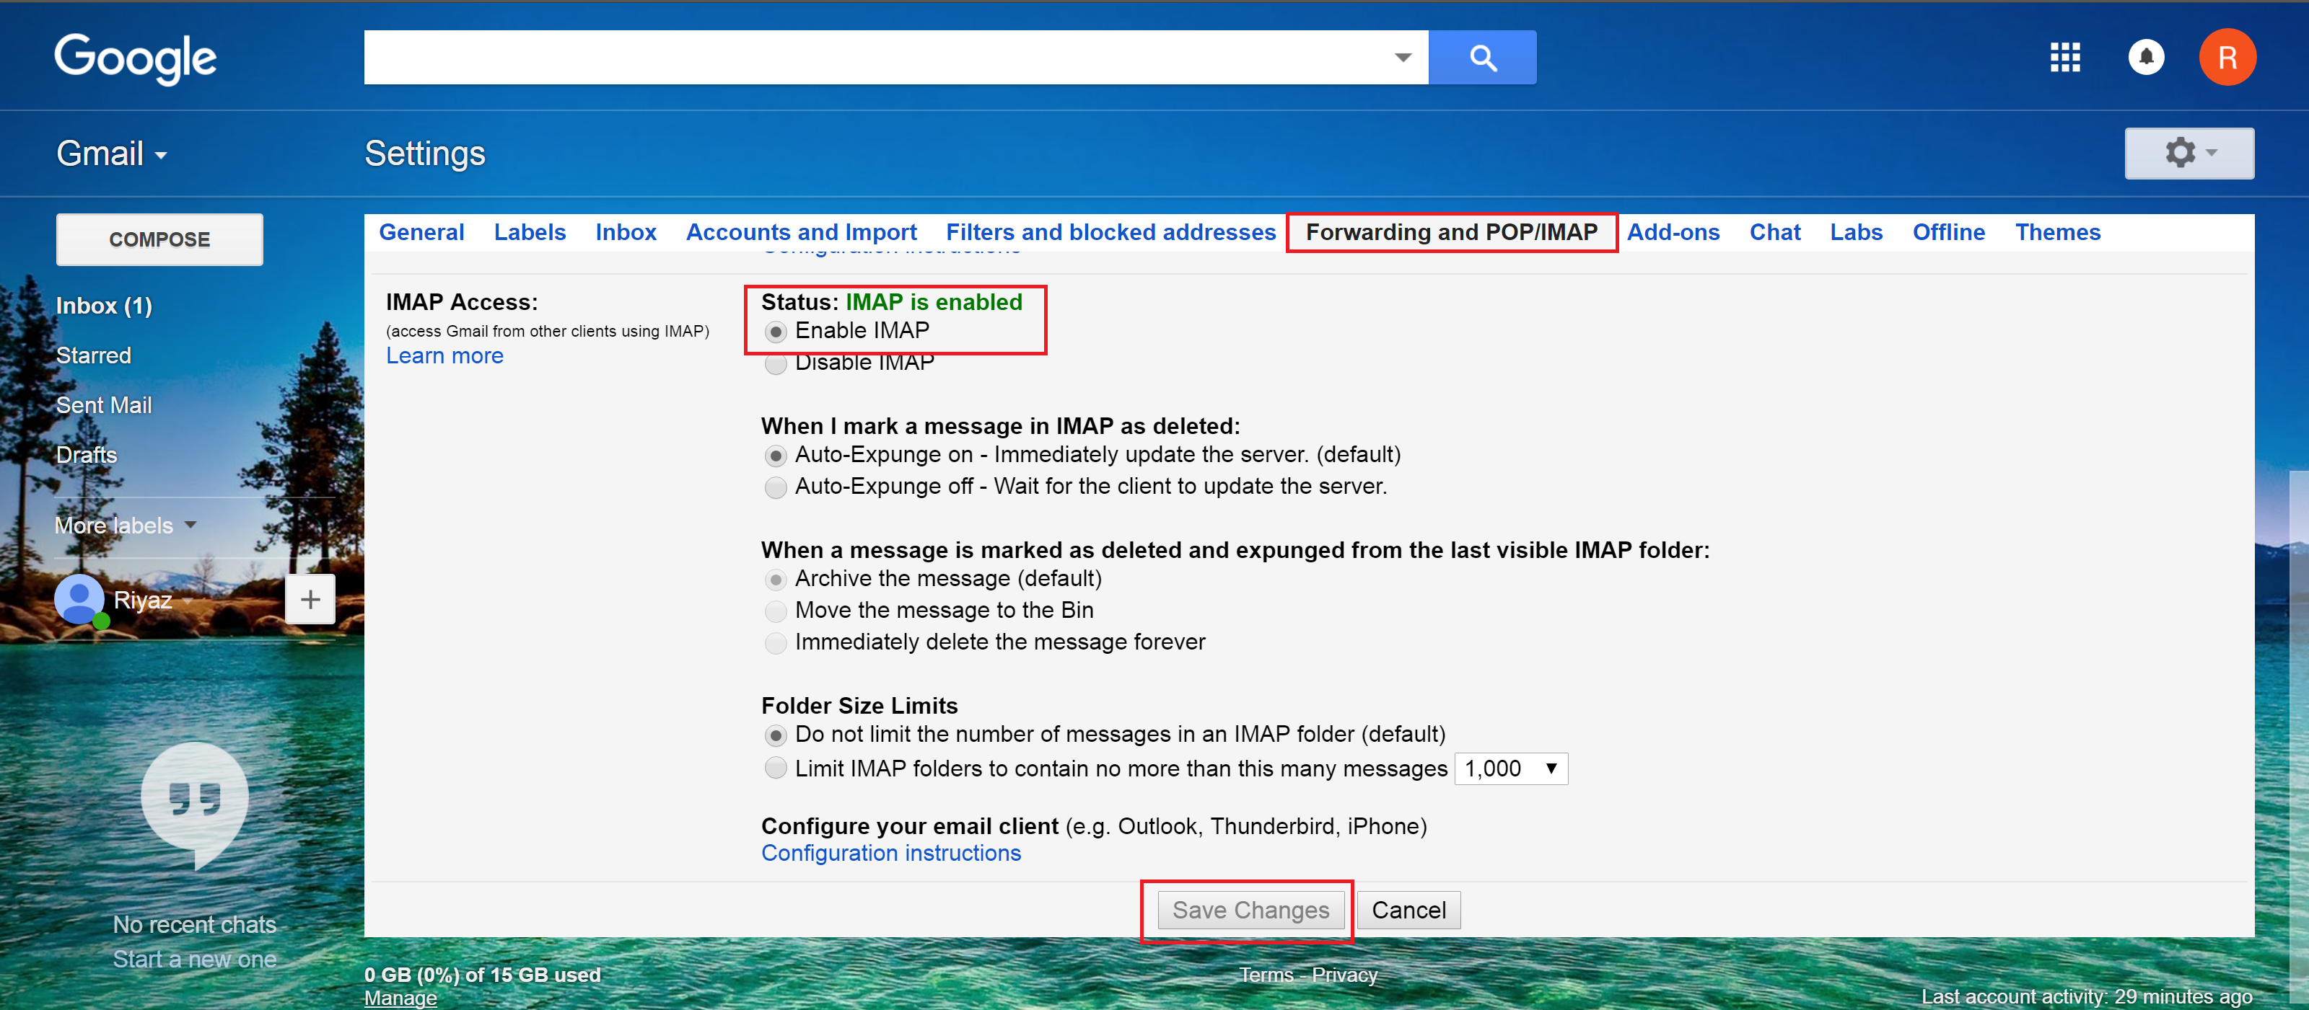

**2.Enable Allow Less Secure Apps**

Click on **My Account** in G-Mail.

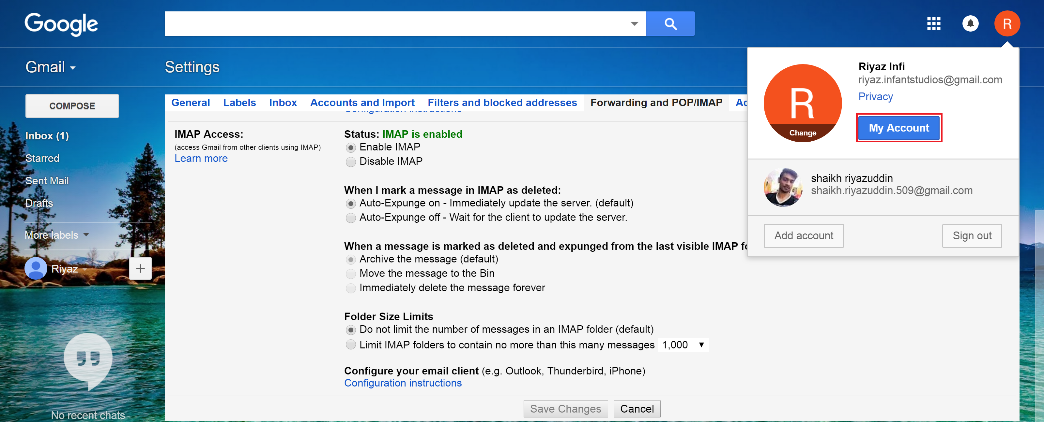

Then click on **Sign-in & security**

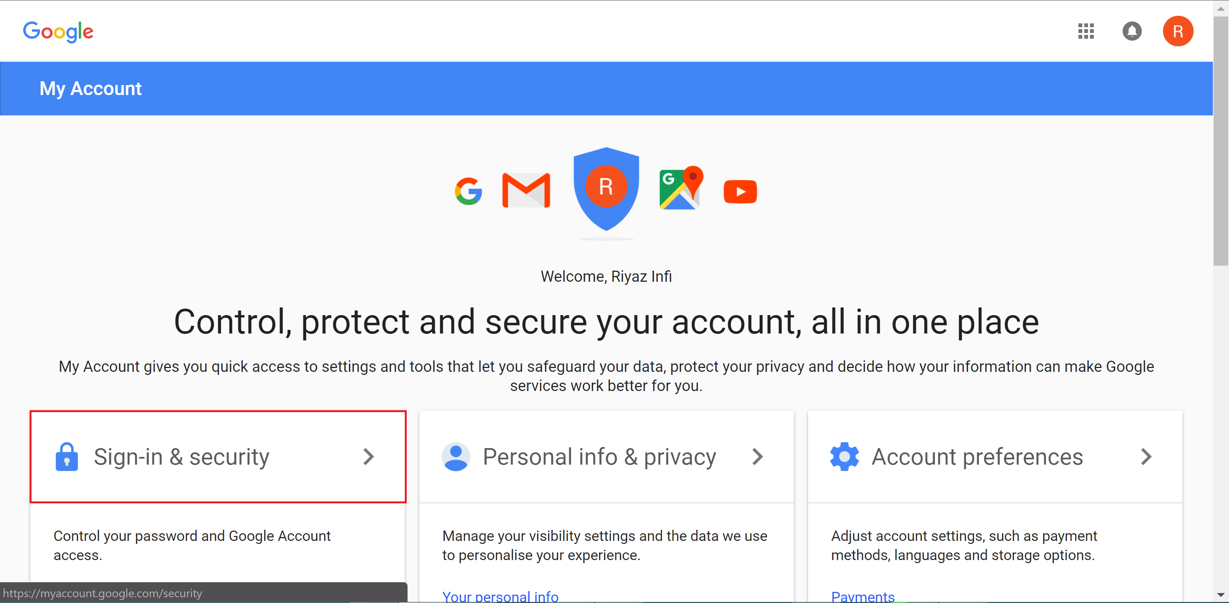

Select **Sign-in & security** And Enable the option **Allow less secure apps**

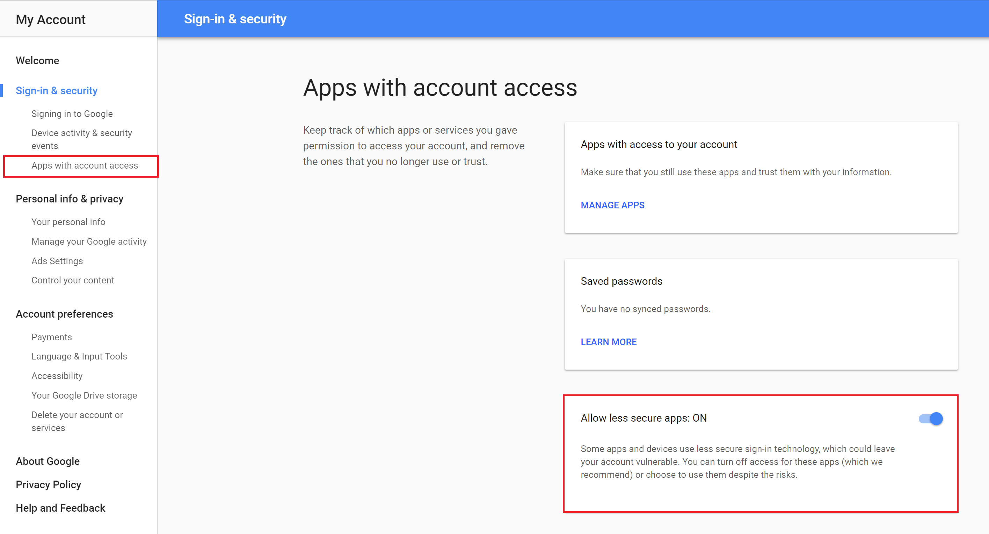

With this now our Gmail account is ready to be used by our application.

2.Downloading and Install the Composer for php in our xampp Server

Download and run Composer with this link- [Composer-Setup.exe](https://getcomposer.org/Composer-Setup.exe) - it will install the latest composer version whenever it is executed.

During Installation Composer setup will ask for the php.exe file.

Select the correct location for the setup to continue in our case it will be the Selected option.

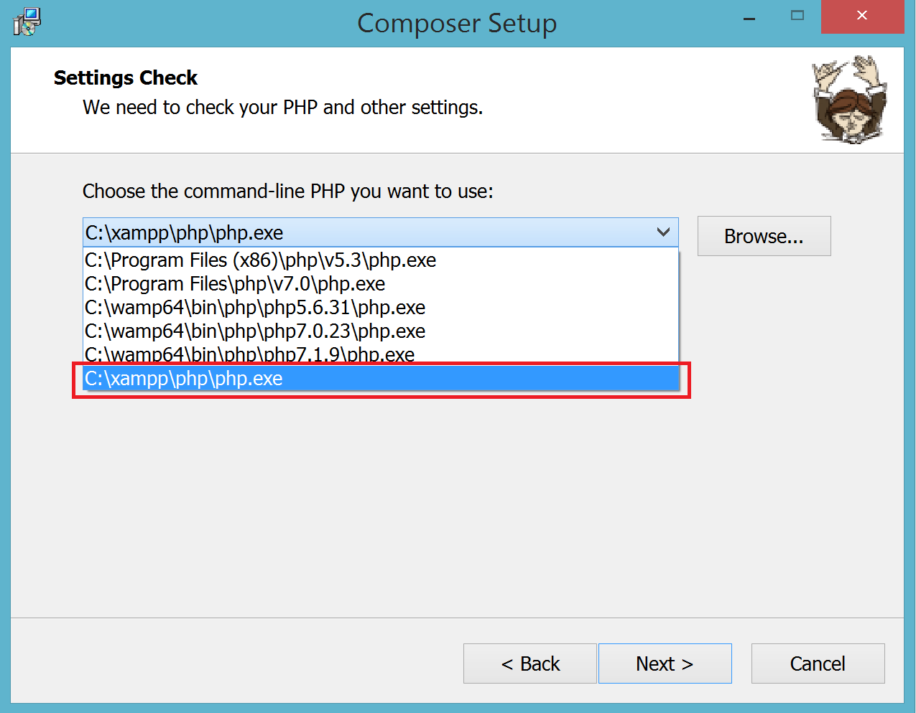

Once the installation process is done we can now use the composer

3.Installing PHPMailer

Goto **Start** on windows, search for **cmd** or **command prompt** and **Run as administrator.**

Click on **Yes**

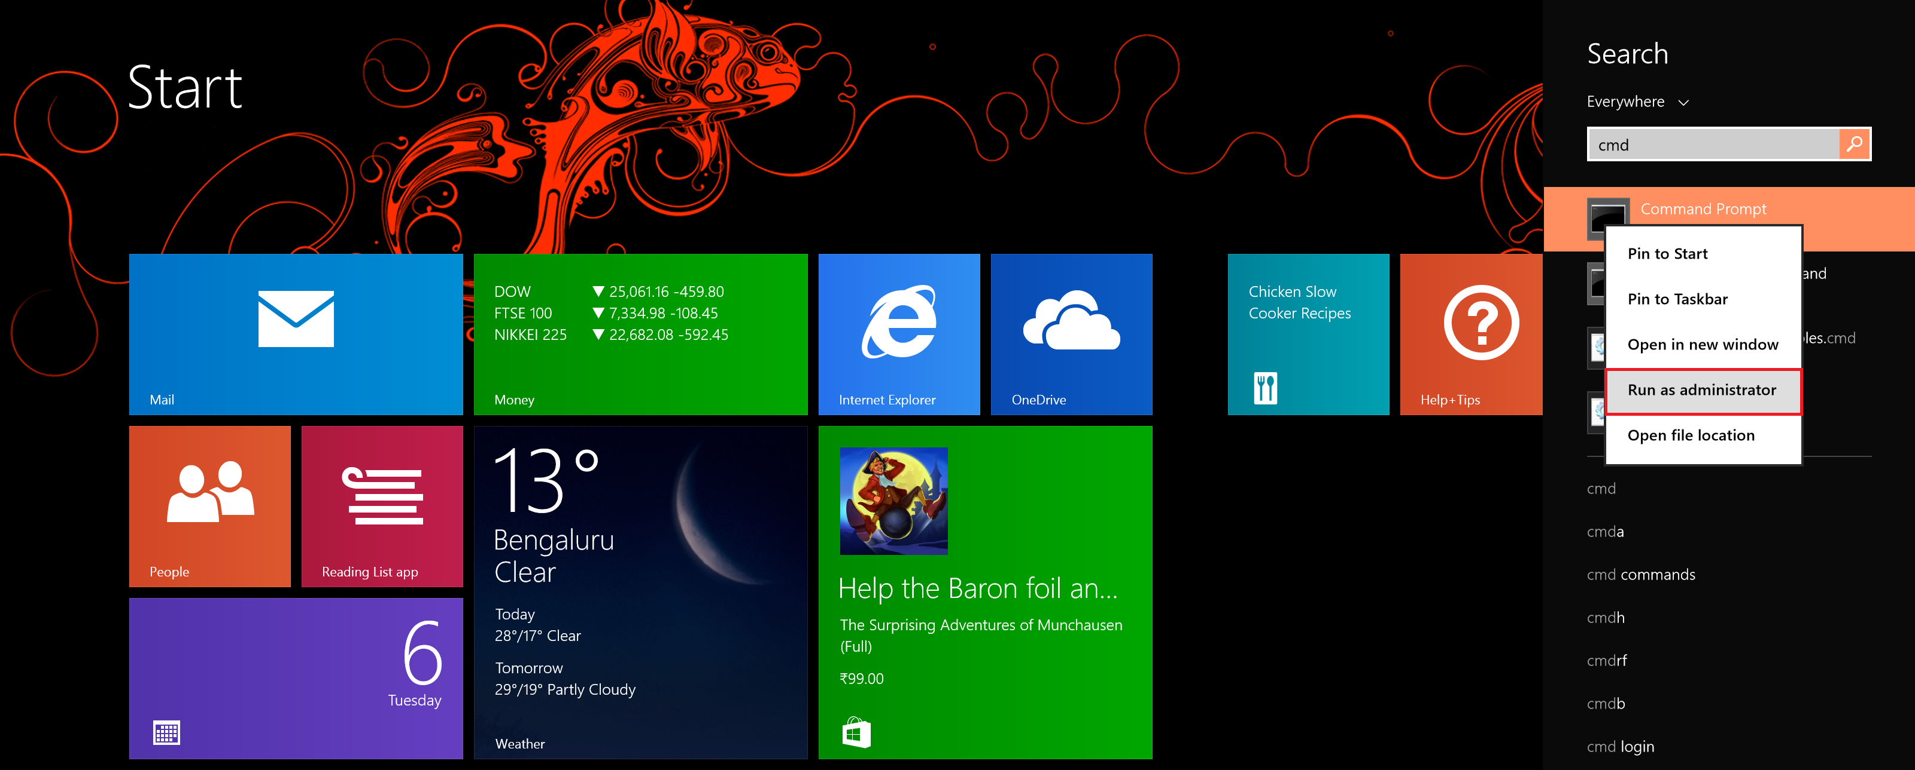

And now redirect the command prompt to your project folder

**cd C:\xampp\htdocs\yourproject**

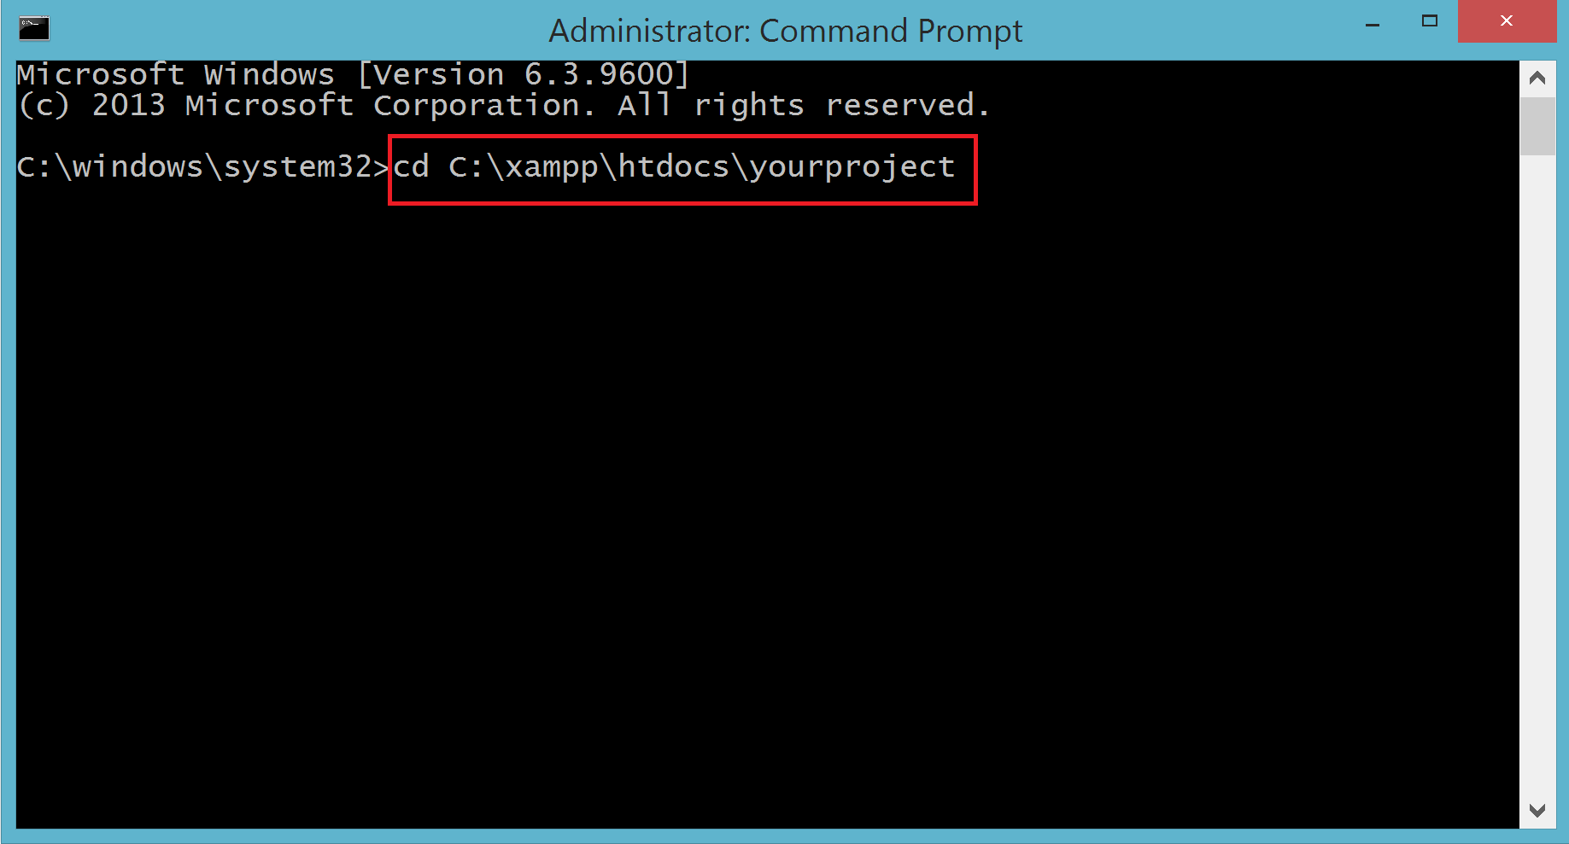

After you have redirected the cmd to your folder just run this command to install the PHPMailer in your project

**composer require phpmailer/phpmailer**

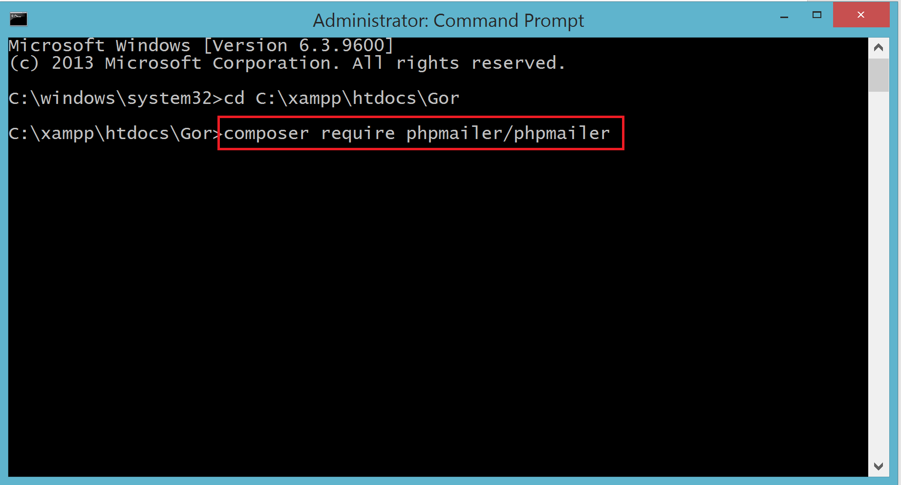

Once the command is been executed successfully you will have these three things in your project folder(vendor folder, composer.son and composer.lock).

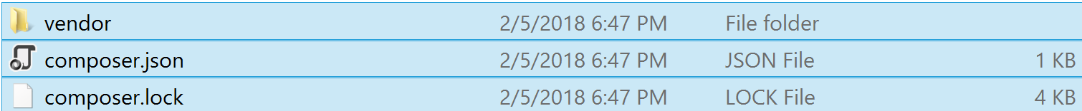

Once the PHPMailer is been successfully installed we can now work with our Code

Create a mail.inc.php file in your project folder

For our demo purpose we are creating the file in **C:\xampp\htdocs\Gor\mail**

Contents of mail.inc.php file

**<?php**

**// Import PHPMailer classes into the global namespace**

**use PHPMailer\PHPMailer\PHPMailer;**

**use PHPMailer\PHPMailer\Exception;**

**function mail_file ($to,$subject,$body,$altBody,$dir){**

**//Load composer's autoloader**

**require 'vendor/autoload.php';**

**// Passing `true` enables exceptions**

**$mail = new PHPMailer(true);**

**try {**

**//Server settings**

**//$mail->SMTPDebug = 4; // To Debug this code**

**$mail->isSMTP(); // Set mailer to use SMTP**

**$mail->Host = 'smtp.gmail.com'; // Specify main and backup SMTP servers**

**$mail->SMTPAuth = true; // Enable SMTP authentication**

**$mail->Username = 'yourgmailaddress@gmail.com'; // SMTP username**

**$mail->Password = 'yourpassword'; // SMTP password**

**$mail->SMTPSecure = 'tls'; // Enable TLS encryption, `ssl` also accepted**

**$mail->Port = 587; // TCP port to connect to**

**/* allow insecure connections via the SMTPOptions property introduced in PHPMailer 5.2.10**

**(it's possible to do this by subclassing the SMTP class in earlier versions),**

**though this is not recommended as it defeats much of the point of using a secure transport at all:**

**You can also change these settings globally in your php.ini,**

**but that's a really bad idea;**

**PHP 5.6 made this change for very good reasons.*/**

**$mail->SMTPOptions = array(**

**'ssl' => array(**

**'verify_peer' => false,**

**'verify_peer_name' => false,**

**'allow_self_signed' => true**

**)**

**);**

**//Recipients**

**$mail->setFrom('riyaz.infantstudios@gmail.com', 'Infi');**

**$mail->addAddress($to); // Add a recipient**

**$mail->addReplyTo('riyaz.infantstudios@gmail.com', 'Infi');**

**//Attachments**

**$mail->addAttachment("$dir","Details.pdf");**

**//Content**

**$mail->isHTML(true); // Set email format to HTML**

**$mail->Subject = "$subject";**

**$mail->Body = "$body";**

**$mail->AltBody = "$altBody";**

**//Sending the Mail**

**$mail->send();**

**//Returning the result**

**$result= 'E-Mail has been sent';**

**return $result;**

**} catch (Exception $e) {**

**$result = 'Message could not be sent. Mailer Error: $mail->ErrorInfo';**

**return $result;**

**}**

**}**

**?>**

Once the mail.inc.php is been created we can now include this file in our project to send mail by calling this and passing the variables.

//save pdf

$dir="Location of the File";

//saving mail data

$to = ”emailofuser@send”;

$subject = "User Details";

$body = 'This is the HTML message body <b>in bold!</b>';

$altBody = 'This is the body in plain text for non-HTML mail clients';

//including mail php

require("mail/mail.inc.php");

//Calling the mail function

if (isset($dir)) {

mail_file($to,$subject,$body,$altBody,$dir);

}

If all good the mail we sent .